Major League Baseball Pitch Analysis

Hao-Ren Cheng

[hac161@pitt.edu](mailto:hac161@pitt.edu)

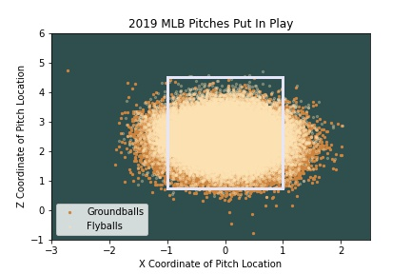

The figure shows the location that every single baseball that pitches put in play in 2019 in the Major League. In play pitches included groundballs and flyballs, which is corresponded to ‘peru’ dots and ‘moccasin’ dots. The X and Y axis represents the X and Z coordinates for each pitch. The size of the scatter is set to 5 to display the density within the big cluster. There is also a rectangle drawn on the figure to show the exact location of the strike zone.

* Baseball is a prevalent sport in the US
* Does pitch location influences the result that put in play?
* Low position pitches tend to have more groundballs

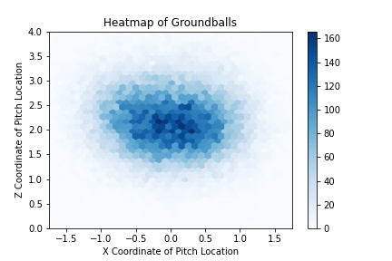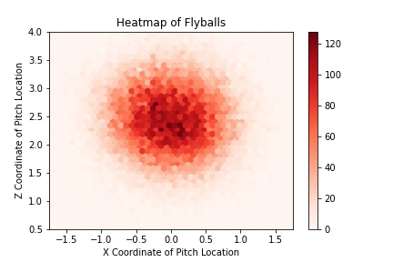

This figure shows the heat map of the location of each pitch that was put in play. The figure is using the ‘hexbin’ to create a 2D hexagonal bin plot to visualize the density. The X and Y-axes are the same compared to the previous figure. I created two subplots to separate the groundballs and flyballs, and the difference along with them was little, however, flyballs tend to have a higher Z coordinate of the pitch location and it was consisting to my guess.

Conclusion

Baseball is always a big part in my life, I’ve enjoyed watching baseball since I was a child. After I visualize the locations of pitches, I can tell that data analysis and visualization is very useful in this sport. We can find patterns to make plans such as pitching lower to have a greater chance to get a double play. Although the pitches are not significantly different from each other, we still can conclude that pitch location can influence the result that was put in play.

Reference:

Data source: <https://www.kaggle.com/datasets/pschale/mlb-pitch-data-20152018>

Github repo: <https://github.com/MUwilliam/INFSCI-2415-final>